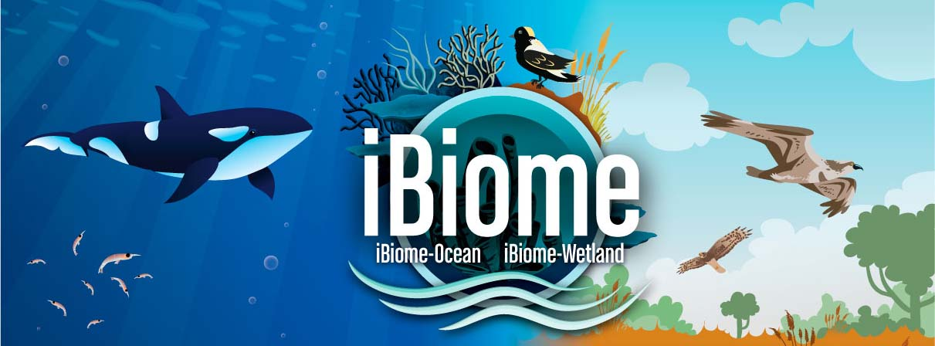

Engaging Students in Environmental Stewardship through Game-based Learning

Many educators agree games can be effective tools for helping students review and retain curriculum content. But some worry that an increase in screen time and digital usage alienates students from the natural world, making them apathetic about environmental conservation. Our research shows games can, when used properly, increase students’ engagement with environment science.
Introduction
We surveyed 45 middle school students at Centennial Sr. Public School in Brampton, Ontario, Canada, about their experiences playing iBiome-Ocean: School Edition. Students were asked what parts of the game they played and what they liked and disliked about the game. The results, summarized below, show iBiome-Ocean: School Edition was an engaging tool that helped students review material they were learning about ecosystems, food webs and ecology, and prepared them to be better environmental stewards.
Key Findings:
- Students learned how ecosystems are impacted by changes in species’ population. Almost all students (90 percent) surveyed did virtual experiments where they added species to the virtual ecosystems they built. Most of those students (78 percent) earned game badges associated with such experiments. This showed that they understood how the delicate balance of ecosystems works.
- Students learned how modern technologies can contribute to environmental damage and also how they can use these technologies in an environmentally sustainable way.
- Students liked building virtual biodomes, and receiving rewards for their work and were motivated to keep playing.
- Students recognized the game was educational. While many enjoyed the doing experiments in the game, several said learning about the classifications of different species was their favourite part. This shows that, when used well, games reinforce educational information, instead of distracting from it.

Game engaged students learn about Biology and Ecology
The majority of students who played iBiome-Ocean: School Edition said it taught them about how ecosystems work. They learned this by building and changing ecosystems, called biodomes, in the game. Students perform virtual experiments in their biodomes by increasing the population of one specie at a time. If they increased two species as a result for one test, they earned a “Double Jump” badge. If they increased three species for one test, they earned a “Triple Jump” badge. The amount of badges they earned shows their ability to apply what they’ve learned about different kinds of species.
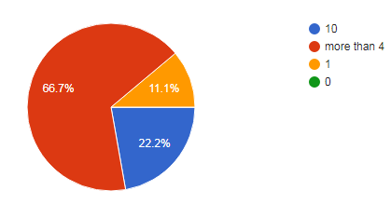
The game clearly helps students learn. Nearly 90 percent of students who completed the survey said they added species to their biodome. Of those, almost 78 percent got badges. Almost 90 percent of students who earned badges received more than four. Nearly a quarter of students – 22.2 percent – got 10 badges. This shows students remembered, and knew how to apply, the food web information they learned about ecosystems.

Game empowered students to improve the environment
This game also taught students about how technology impacts the environment. Students can build the following everyday items: plastic bottles, plastic bags and disposables, air conditioners and bathtubs, and cars and trawlers. Those technologies are selected as they are associated with plastic pollution, ocean acidity and overfishing, three challenging issues for oceans. After they build technologies, they will unlock the related story piece – called “The Ocean and Us” in the game. Students can improve the technologies as well.
100 percent of students built some technologies, 49 percent of the students had built all technologies.
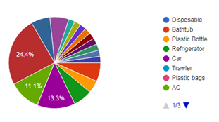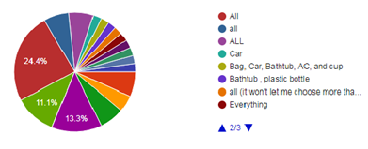
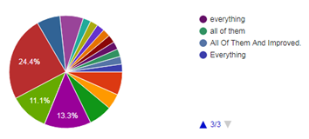

Most students who were surveyed said iBiome-Ocean: School Edition taught them about how technology contributes to pollution and CO₂, and how this affects marine life. Many students wrote about how pollution and overfishing harms marine ecosystems. “I learned that in the world there are lots of problems around animals,” one student said, adding these problems were “more than I expected.” Students saw the tensions between human convenience and environmental damage. “I learned that we build a lot of technology to help us,” wrote one, “but we are not thinking about the animals that live in the ocean. A lot of them are dying because of us and our technology.”

Many students listed building technologies as their favourite part of the game. One wrote that they liked this part of the game the most because, “it gives information about what you build and how it affects the ocean.”

iBiome-Ocean: School Edition also empowered students to become better environmental stewards. After they build technologies, they can improve them and unlock related “The Ocean and Us” stories. 71 percent of all students in our survey did that. Through those stories, students learn how to use the technologies they built in environmentally responsible ways. “I learned what I can do to save the environment,” wrote one student. Another said the game taught them “there are ways we can help the world every day.” This shows that rather than contributing to a disconnect between students and the natural environment, games can become a way to connect students to the natural world in meaningful ways.

Unparalleled game-based learning experience about nature

iBiome-Ocean: School Edition includes 54 tasks (game levels) and progressive challenges, such as adding species and building technologies, kept students engaged with the content. The ability to earn rewards through badges motivated them. Many wrote they enjoyed this challenge. One student compared double and triple badges to opening supply drops in Call of Duty, a very popular video game. One student said building technologies was a “fun” way to be creative and learn about science. Another said they like this experiment because it showed them how technologies impact the environment. Building a virtual biodomes and doing virtual experiments are unique values that traditional environmental education tools can’t provide. With the well designed game features, iBiome-Ocean: School Edition provides an unparalleled game-based learning experience for students.

Students welcomed the educational aspects of the game

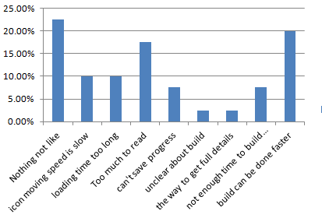
Students understood – and many liked – the fact that the game was educational. Many reported their favourite part of the game was learning which species were predators and prey or building food webs. Some said they enjoyed the virtual experiment that reviewed what they learned, and reading the text boxes about different species.
Which part of the game you did not like?

However, not all students liked the amount of reading the game required. Several students said they thought the game included too much text. Not all students thought this was bad. Some said the game was still interesting, even though there was a lot of reading. Other students listed the amount of text as their least favourite part of the game. Many complaints students had about the game were technical in nature. No student complained about the game being educational.

In conclusion, this survey of middle school students shows games have great potential to engage young people in environmental stewardship. Students enjoyed having challenges throughout the game, and that featured earned iBiome-Ocean: School Edition comparisons to popular, non-educational video games. These elements also gave students the opportunity to apply the knowledge they acquired during gameplay. Students knew the game had an educational purpose, yet they still enjoyed playing it. Several said there was nothing they would change about the game. Educators should be encouraged to know students value learning environmental science through digital games.

You can download the full survey report here: https://schools.springbaystudio.com/Students_survey_1207.docx

